
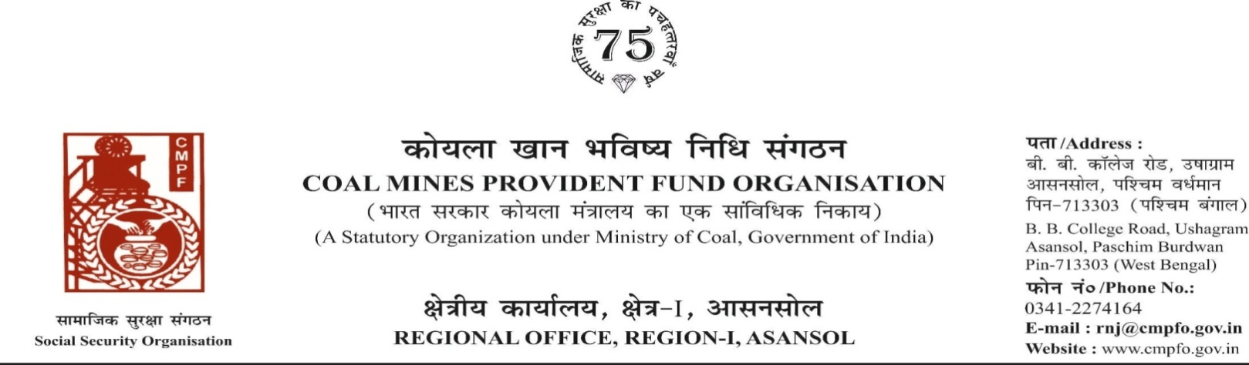
Ref. : CPF/118/Misc/RNJ/LC/OUT/R-I/ASN/ Date : 12/08/2025

To,

The Regional Commissioner
Coal Mines Provident Fund
Police Line
Dhanbad , D-I
Dhanbad (jharkhand)
PIN-826014

Sub:- Inter Regional Transfer of Ledger Card, DA, PS -3 & 4
Ref:-CPF/16/DHN-11/Tr.of L.C./D-I/337/1144 Dated:13-NOV-2024
Sir,
In view of the revised Procedures prescribed in Procedure Office Order No-35 Dated-12.02.1975 of CMPF Commissioner,Dhanbad, I am to state that the Ledger Cards of the following members along with Declaration in Form "A" Form-I (Pen),PS-3 & 4 may kindly be forwarded to this office as the member(s) is /are working in this region.
It may kindly be ensured that the posting in the Ledger Cards may be made updated for the periods the member was working in your Region.

SL. No | Name of the member | CMPF A/C No | Name of the colly where member worked in this region | Name o the colliery where member working in your region
1 | Sri Prabhat Ranjan Jha | BKR/29/4959 | Jhanjra Area, ECL  (RNJ/40) | Moonidih Project  (DHN/II)

Encl. : Orginal One Ledger Card

Yours faithfully

Assistant Commissioner

